Zendesk Agent User Guide

Table of Contents
- Introduction
  - Purpose of this Document
  - Audience
  - Document Revision History
- Getting Started
  - Logging In
  - Dashboard Overview
- Ticket Views
  - Opening a View
  - Editing a View
  - Creating a View
  - Sharing a View
- Managing Tickets
  - Creating a Ticket
  - Searching Tickets
  - Assigning Tickets
  - Updating Ticket Status
  - Merging Tickets
  - Internal & External Notes
  - Creating Side Conversations
- Zendesk Best Practices
  - Email Forwarding from Outlook
  - Zendesk Support Groups
  - Helpful Videos

1. Introduction

Purpose of this Document
This Zendesk User Guide aims to provide a comprehensive resource for users to efficiently navigate and utilize the Zendesk customer support platform.

Audience
This document is intended for all support agents who will be using Zendesk within our organization.

Document Revision History
- Version 1.0 (9/6/23): Initial Release
- Version 1.1 (Date): Updates and revisions

2. Getting Started

Logging In
- Open a web browser and navigate to [https://johnrwhite2720.zendesk.com].
- Click the "Continue with 365 - SSO" button to login automatically.
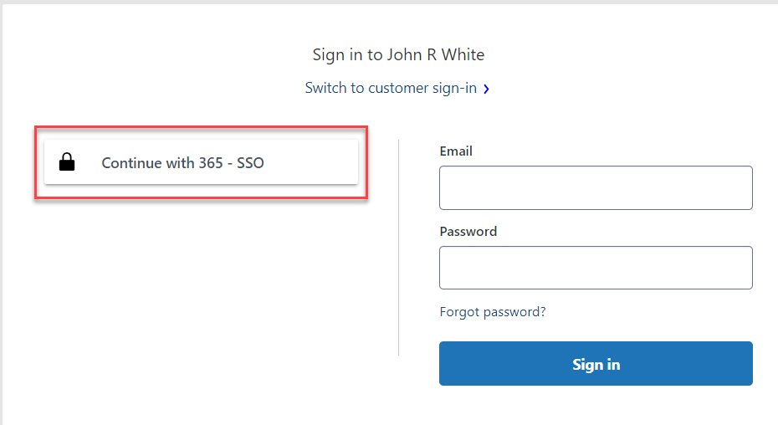

Dashboard Overview
- The Zendesk Dashboard will contain an activity feed on the left-hand side of the page with updates to your recent tickets, along with a listing of all Open tickets either assigned directly to you OR to a group that you belong to.
- You can filter between those belonging only to you and those belonging to your groups.
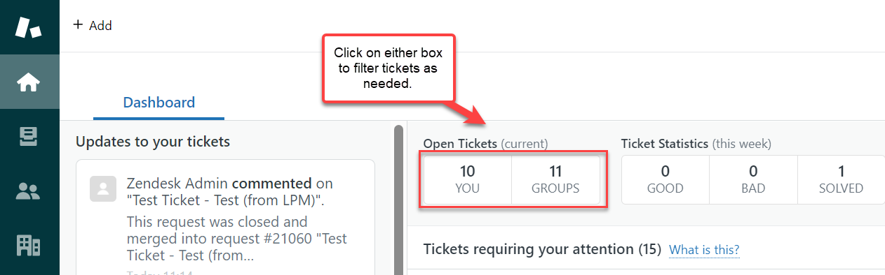

3. Ticket Views

Opening a View
- Views are displayed as a list in the Views pane. The first 12 of your shared views and 8 of your personal views appear in the list. If you have additional views, you can access them by clicking Manage views at the bottom of the list.
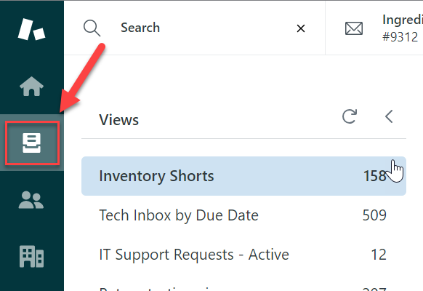
Tip: If you're trying to reorder the tickets within a view, not the list of views itself, see I can't reset the order of tickets in my view after selecting a column header.
To select and display a view
  - Click the Views icon () in the sidebar, then select a view from the list.
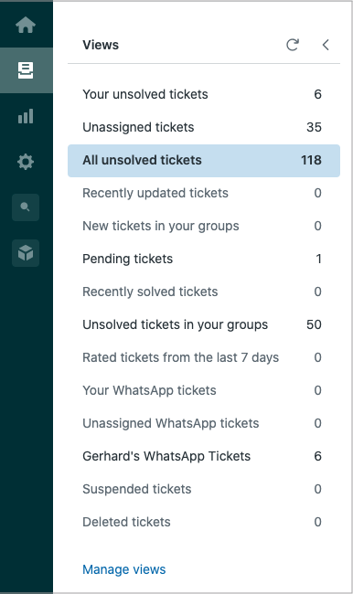
  - The view opens and displays the associated tickets.
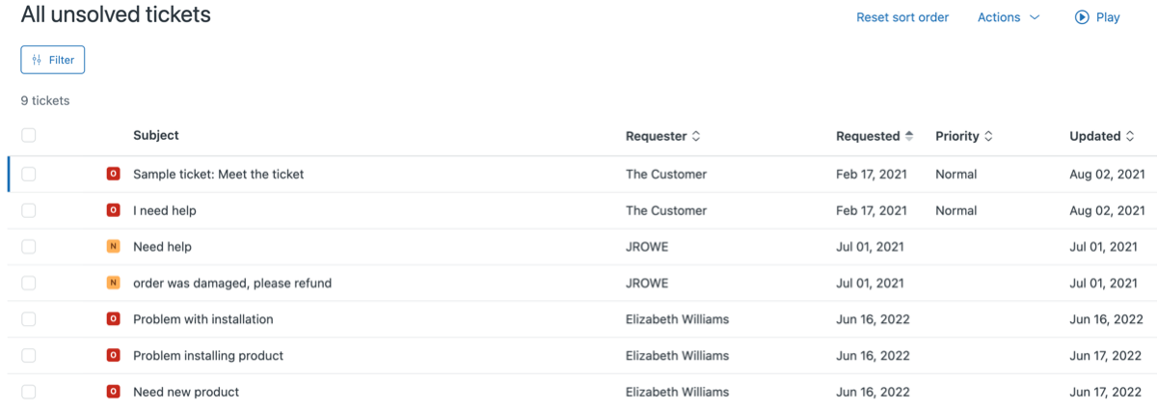

  - You can sort the view in ascending or descending order by clicking the sort icon () on certain column headers. Reset the sort order on the view by clicking Reset sort order. You can also filter a view (see Filtering tickets in a view to refine results).
Note: Tickets are automatically archived 120 days after they are closed. Archived tickets are not shown in views. This helps views to display faster. See About ticket archiving.

Editing a View
To edit a view from the views list
- In Support, click the Views icon () in the sidebar, then select a view.
- Click the Actions menu in the upper right, then select Edit view.
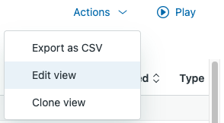
- Modify the title, conditions, formatting, and availability as needed.
- When you are finished, click Save.

Creating a View
- Select “Manage Views” at the bottom of the view list on your homepage. Click Add view.
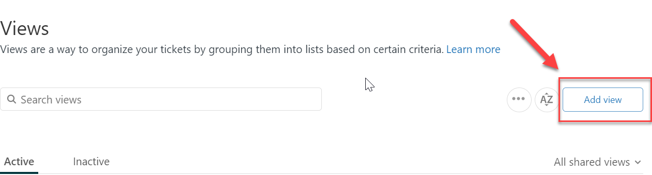
Alternatively, you can clone an existing view. (see Cloning a view).
- Enter a Title for the view.
- Enter a Description for the view.
- Select an option to determine Who has access:
  - Any agent, available to all agents.
  - Agents in specific groups, available to agents in specified groups. Select groups from the menu, then click away when finished.
  - Only you, available to you as a personal view.
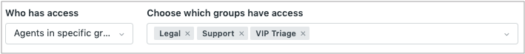
- Click Add condition to set up the view to meet All or Any conditions.
The conditions define this collection of tickets.
- Select a Condition, Field operator, and Value for each condition you add.
See Building view condition statements.
- Click Preview to test the conditions.
- Set the formatting options:
  - Drag the Columns into the order you want and click Add column to add up to 10 columns.
Status is always shown as colored icons to the left of your view's columns; you don't have to add it. Multi-select fields are not supported.
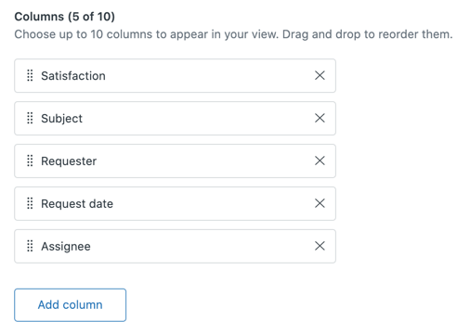
  - Under Group by, select the ticket field you want to use to group tickets, then select Ascending or Descending.
Tip: If you select Request date from the Group by drop-down list, any settings you change in the Order by drop-down list will not be applied.
  - Under Order by, select a ticket field to use as the default data to order tickets, then select Ascending or Descending.
- Click Save.
The view is created.

Sharing a View
You can share a link to a view with other agents. Normal access permissions based on the availability set for the view apply to the users who click the link.

To share a link to a view
  - In Support, open the view you want to share.
  - From your web browser address bar, copy the URL to the view.

You can now share this URL with other agents.

4. Managing Tickets

Creating a Ticket
- From the dashboard, hover your mouse over the "+ Add" icon to bring up a drop down menu and select “Ticket” to create new request.
- Fill in the required information.
- Click "Submit."
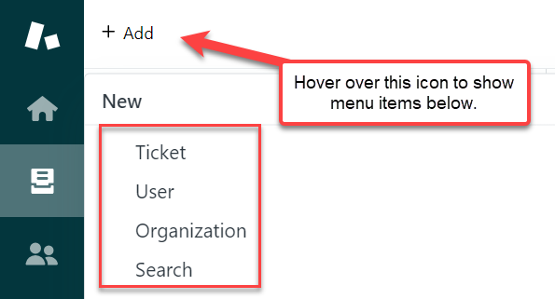

Searching Tickets
- You have the option of using the basic search feature to search by ticket#, customer, or keywords by clicking on the “Search” button within the same drop-down menu shown above.
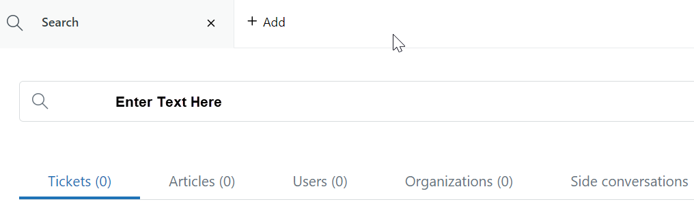

Assigning Tickets
- After clicking on a ticket to open it, you can control who the ticket is assigned to by updating the “Assignee” field on the left side of the page.
- You can assign to yourself by clicking “take it” OR you can assign to someone else by choosing an agent from the drop-down menu under “Assignee”.
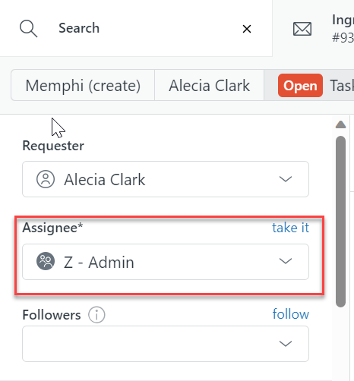

Updating Ticket Status
- You can update the ticket status by clicking the drop-down arrow in the bottom right corner of the screen beside “Submit as [current status]”.
  - Open – Ticket is actively being worked
  - Pending – Waiting on feedback or response from customer
  - On-hold – Waiting on feedback or resolution from 3rd party vendor
  - Solved – Ticket is resolved
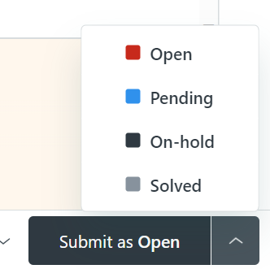

Merging Tickets
- Duplicate tickets can be merged together by clicking on the 3 vertical dots icon in the upper right of the page and clicking the “Merge into another ticket” icon on the drop-down menu.
- After this option is clicked within a ticket, that ticket will be closed and merged into the ticket that you choose.
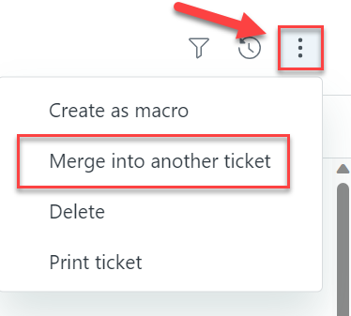
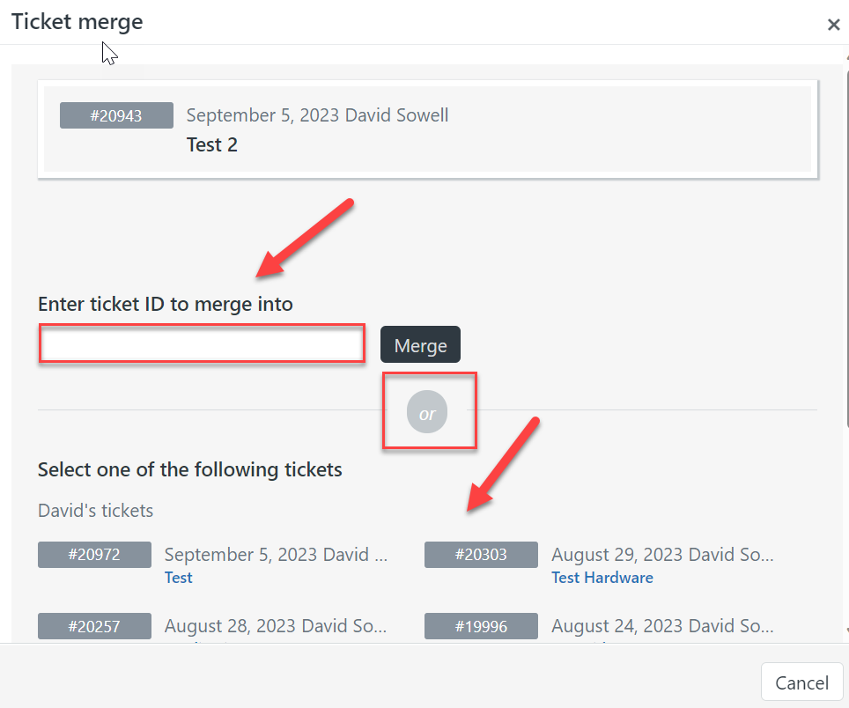

Internal & External Notes
- When you enter a note on a ticket, you can select whether that note will be “Internal Only” or “Public Reply”. Default option is currently set to “Internal note”.
- An “Internal note” will only be visible to Zendesk agents within the JRW organization.
- A “Public reply” will be visible to agents and customers.
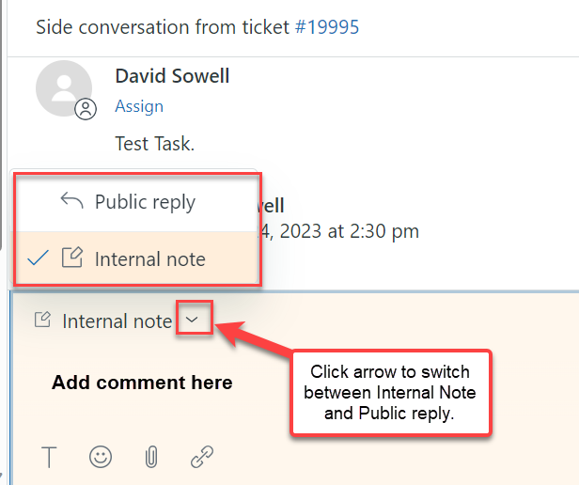

Creating Side Conversations
- **Important** - Creating a side conversation ticket or email is the best way to manage action items or requests from multiple groups on the same ticket.
- Side Conversation Ticket – This option should be utilized when there is an action item needed from another group on an existing ticket. By creating this request as a side-conversation, you are creating a separate but linked ticket that will remain open for the intended group until resolved.
  - This ensures that the separate request does not fall off the radar of the intended group due to assignment issues on a single ticket.
  - The side ticket will always maintain a link back to the original request for easy tracking and reporting.
  - You can choose which person or group the ticket will be assigned to using the drop-down menu option.
  - You have the option of copying select or all notes from the existing ticket to the new ticket, as well as the option to keep the original tags, followers, or form from the existing ticket.
- Side Conversation Email – This option should be utilized when you want to keep a conversation containing sensitive content separate from the original ticket comments OR when you simply have a question or are requesting related information from another group or 3rd party.
  - By creating a side conversation email, you can easily track open conversations and requests separate from the clutter of the main ticket body.
  - This option also prevents internal communication with sensitive content from accidentally being sent to a customer.
- See below for directions on creating a side conversation:

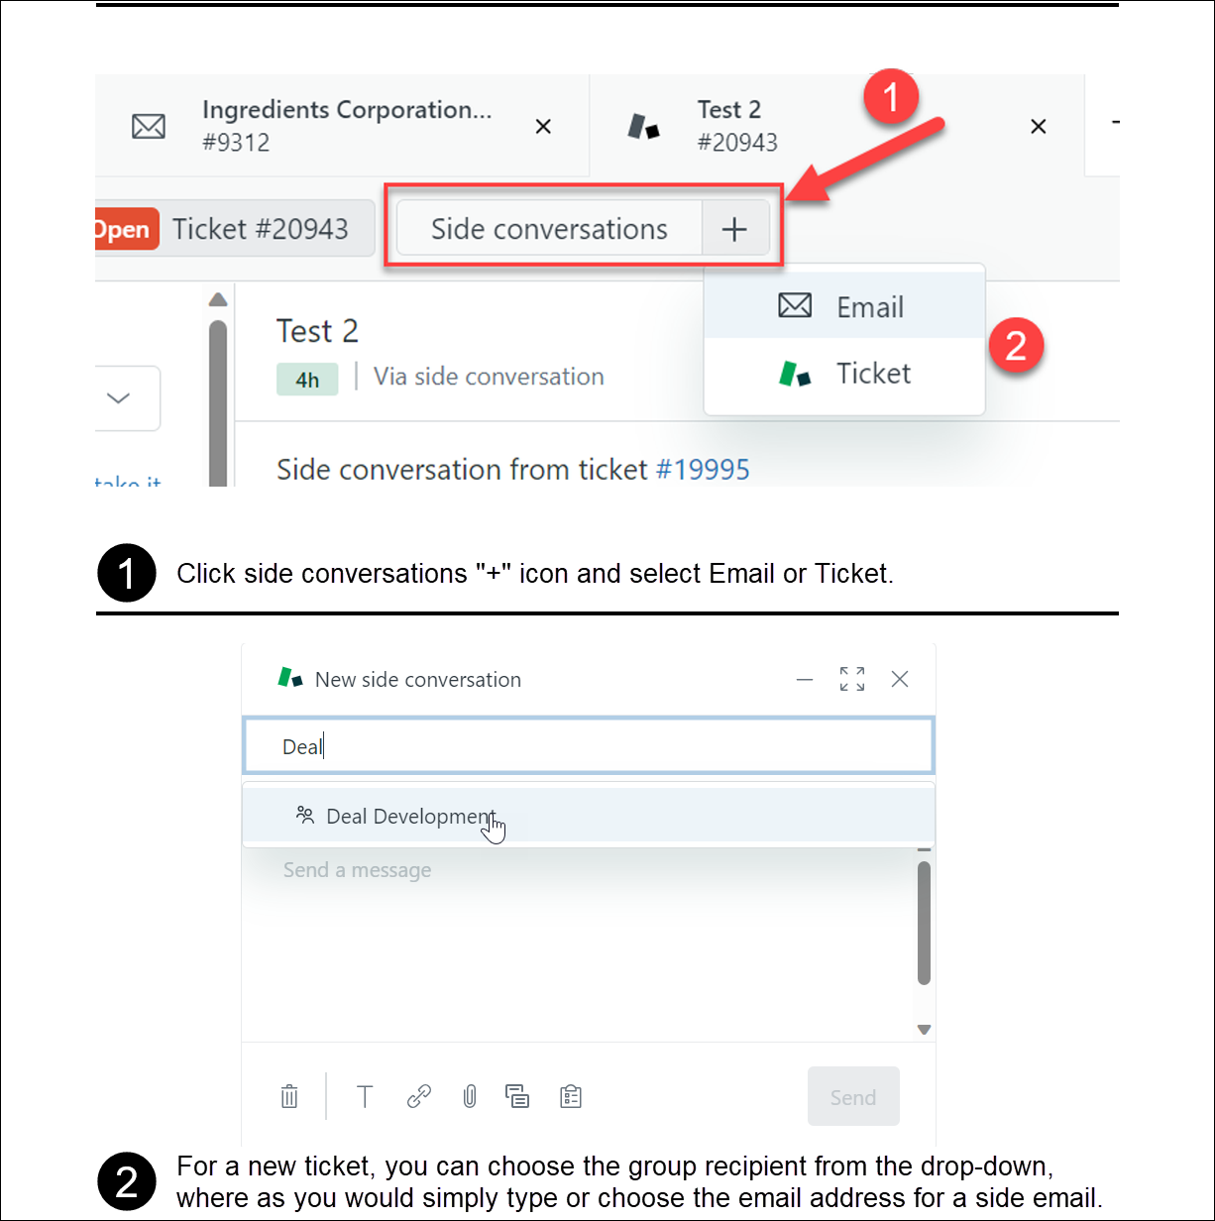

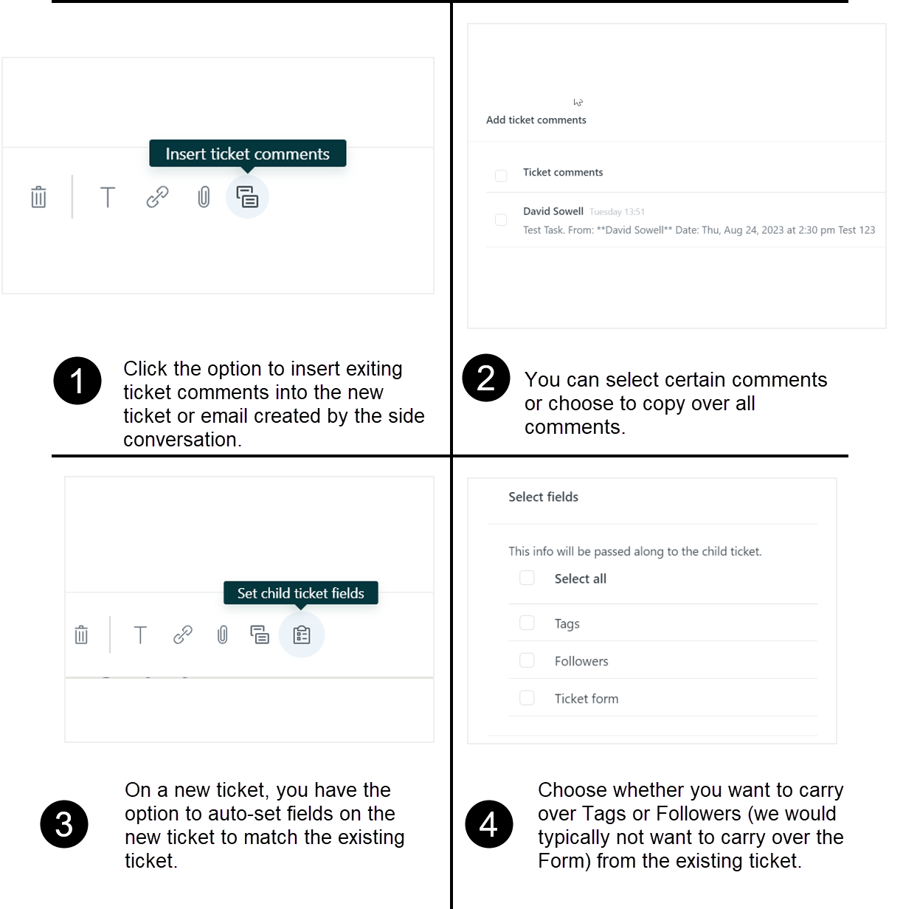

5. Zendesk Best Practices

Email Forwarding from Outlook
**An email conversation should not be forwarded to Zendesk to create a ticket until you have reached a point where a Support Request is needed.

  - When you are ready to create a ticket, forward the email to a single Zendesk support address to create a ticket with the customer listed as the requester.
    - If you decide to reply to the chain and copy a support address instead, it will create the ticket with you listed as the requester instead of the client.
  - Do not include more than one Zendesk support address on a request, as the ticket will only be created once and having multiple support addresses can cause issues with the triggers setup in Zendesk. (i.e. The ticket is assigned to an unintended group and is overlooked by the intended recipient.)
  - After a ticket has been created in Zendesk, any responses or forward attempts to that email chain will ALL result in a comment being added to the existing ticket.
    - Forwarding an existing email chain for an active ticket to another support address WILL NOT create a new request for that group.
    - If you need to create a new request for another group, you will need to create a completely NEW email addressed to the intended support address. (You may still copy comments from the previous email chain for reference as needed.)

Zendesk Group List

Zendesk Support Address | Associated Group
support@johnrwhite.com | Customer Service
orders@johnrwhite.com | Customer Service
pricingrequest@johnrwhite.com | Deal Development
supplyassist@johnrwhite.com | Procurement
tech.request@johnrwhite.com | Quality Team

Helpful Videos
Creating Child Tickets via Side Conversations (Zendesk feature)
https://www.loom.com/share/e19e4706ce38479cb646e465e4f0a70a?sid=642c9ae0-bff7-4ba6-b625-7c201875415e.
Adding Followers on ticket (Zendesk Feature)
https://www.loom.com/share/599d3bf8c01d44728da89137e20d499f?sid=8f2ffa79-024e-4e05-b6d1-2fcfc131ab19
Creating a Child Ticket via Sweethawk (not native feature)
https://www.loom.com/share/3989b3e383cd4cf3a3553bdfda2e92df?sid=87e50d1f-d733-4c7e-91c0-7219d5719669

